Midseason Recap (2018)

**Standings (Current and Projected)**



*Note: projected results were based on 100,000 simulations using both i) Yahoo projections (see Power Rankings) and ii) each team’s point totals in the first seven games.*

Observations

* **LeSean Hara is a virtual lock to make the playoffs at 93.5%**. Eli’s chances are higher than expected due to a somewhat favorable schedule (the 4 teams he no longer has to play are GoBias Industries, Burnett=Microdong, Gee Whiz Darnell, and Mr. Fan’s Noodle Haus).
* **Shiva Volodarskaya is “leading” the race for the Sacko, with a 51.2% chance of finishing bottom of the table.** Redemption317 and Radical Shizzlam also need to be careful.
* **GOBias Industries** currently sits 2 games back of a playoff spot, but his playoff chances are still 50%. Not surprising given his obscene point totals.
* Somehow, GOBias Industries (124.7 ppg) and Radical Shizzlam (83.6 ppg) have the same record (3-4).
* **Burnett=Microdong** is likely to end his playoff drought this season, with a +80% chance of making the postseason.
* **Gee Whiz Darnell’s** playoff chances (13.2%) are on life support – if I lose against Sackwash Lyfe this week I am essentially out.
* Yahoo’s projections for **Schmop** are very negative (Schmop is ranked 11th in Yahoo’s power rankings). Unfortunately, Schmop still has a 61% chance of making the playoffs because of his easy remaining schedule (5 of 7 final games are against the bottom five in the league).

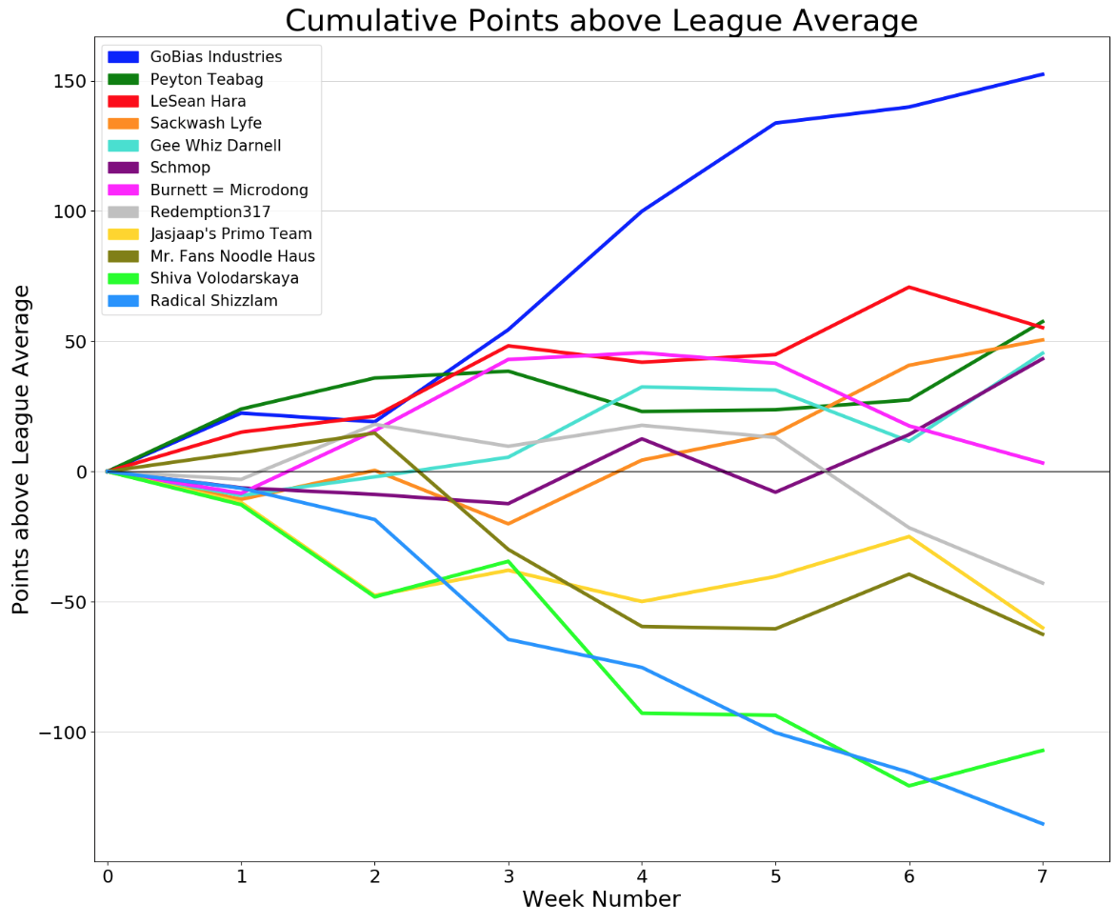

Scoring By Week



Observations:

* Once again, **GOBias Industries** is scoring points at a historic rate. Wolf has recorded 124.7 points per game and is on pace to score 1745.88 total points, which would obliterate the league’s single-season record of 1619.60 (set by GOBias Industries last year).
* **GOBias Industries** is also the first team in league history to score above 100 points in each of its first seven games.
* **LeSean Hara** opened the season with six games over 100 points, becoming the third team to do so (along with Radical Shizzlam in ’16 and GOBias Industries in ’18)
* **Burnett=Microdong** is lucky to be 6-1; Jacobson’s team has struggled the past three weeks (87.6 ppg) and his team ranks 7th of 12 in total points scored.
* **Sackwash Lyfe** is on a tear, scoring 120.48 ppg in the past four games (4-0).
* From a stats perspective, the “most improved” team award belongs to **Peyton Teabag Party**, who is averaging 111.1 ppg (up from 90.1 ppg in 2017).

By and large, fantasy scoring has increased significantly this season, mirroring the NFL’s offensive explosion this year. **Teams are averaging 102.9 points per game in 2018, compared to just 90.8 at this point in 2017**.

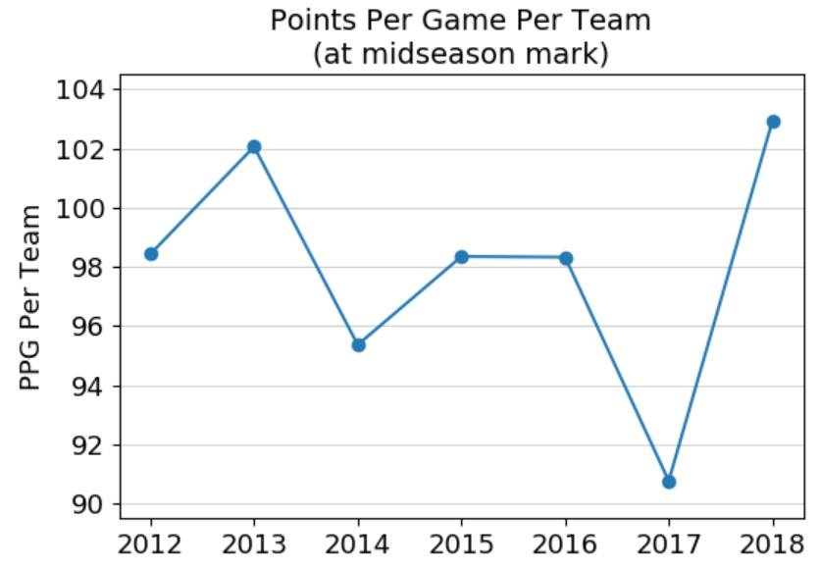

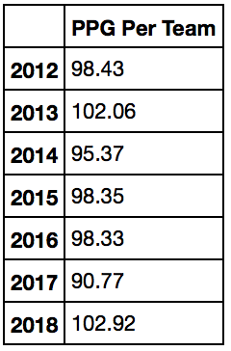

Miscellaneous:

* The highest-scoring player in fantasy (Patrick Mahomes, 190.92 points) is on our league’s lowest-scoring team (Radical Shizzlam).
* Mahomes has scored almost 33% of Heintz’s points this year.
* Emmanuel Sanders is the #3 WR in fantasy this year. (#5 in points per game). Baffling.

The Futility of Draft Day Projections

* At the start of the season, Shiva Volodarskaya was projected go 14-0! His midseason record is 1-6. (Tough luck with Dalvin Cook, Jerrick McKinnon, etc…)

